**Assignment --- MODULE 5**

1. Suppose we have samples from a bivariant Gaussian with mean $\left|\begin{matrix}2 \\ 3\end{matrix}\right|$ and covariant $\left|\begin{matrix}2 & 2 \\ 2 & 3\end{matrix}\right|$, calculate the principle components of the data. The plot of the data is shown below.

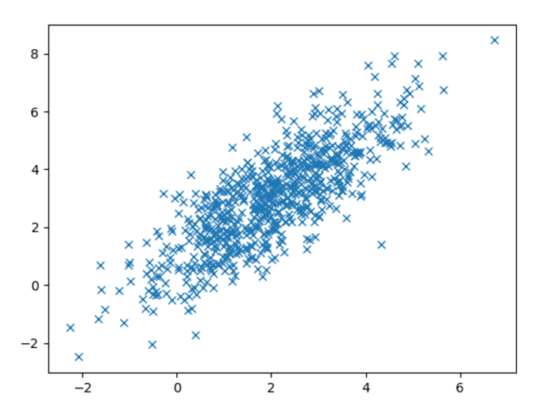

1. What is the variance explained by the first component calculated in question 2.
2. What is the variance explained by the second component calculated in question 2.
3. Fill out the code cells in hw_5.ipynb and answer the questions. Include the answers in your homework document submission as well as in the Jupyter notebook.